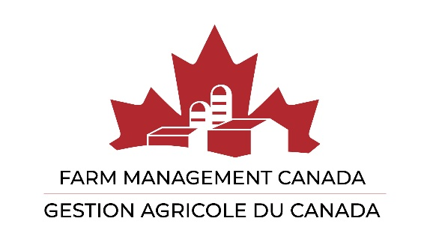

Nominations 2024

Nominations are now being sought for Farm Management Canada’s Board of Directors.

Nominees can be from any of the following member categories:
- Farmer (including Young Farmer)
- Member at Large
- Organization/Association
- Academic Institution
- Corporation

Both nominating persons and the nominee must be residents of Canada and members of Farm Management Canada in good standing. To become a member of Farm Management Canada, visit fmc-gac.com
____________________________________________________________________________________

NOMINATION FORM

We hereby nominate: ______________________ to fulfill a ___________________ (Farmer/Young Farmer, Member at Large, Organization/Association, Academic Institution, or Corporation) Director position on Farm Management Canada’s Board of Directors for elections that will be announced at the Annual General Meeting.

__________________________ (Sign) _______________________ (Print)

__________________________ (Sign) _______________________ (Print)

I hereby accept this nomination and agree to serve a three-year term if elected:

__________________________ (Sign) _______________________ (Print)

Nominees must also submit their biography (maximum 250 words) and photograph.

Nominations can be emailed to info@fmc-gac.com

For further information on the roles and responsibilities of Directors, please contact the Head Office at info@fmc-gac.com.

Nominations MUST BE RECEIVED no later than 17:00 EDT Thursday June 6th, 2024.

