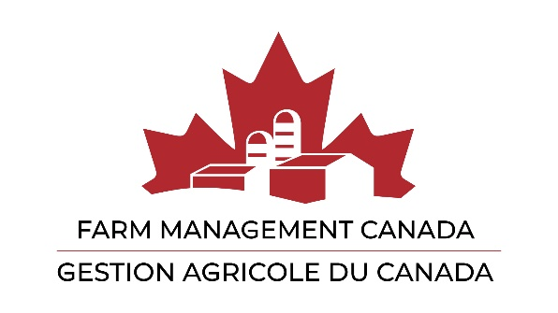

Call for Member Resolutions 2024

What can we do for you?

Farm Management Canada encourages its members to submit resolutions to be addressed at the Annual General Meeting.

This is an opportunity to directly influence the direction of Farm Management Canada’s activities, as well as the organization itself. What better way to make our Board, staff and the membership, aware of issues and items that are important to you?

A Resolution Preparation Form is available in electronic form, and copied below, for those wishing to submit resolutions.

Members are encouraged to seek background information and find out what Farm Management Canada may have already done before submitting a resolution. See our website www.fmc-gac.com for information on activities and initiatives.

Please ensure the resolution is germane to Farm Management Canada's mission and mandate:

Vision
A resilient and thriving Canadian agricultural industry.

Mission
To champion farm management excellence.

Purpose
To be the Canadian organization that facilitates farm management practices through research and education.

Objectives:
- Increase awareness of the principles of farm business management and the potential gains of applying these principles in the management of a farm operation;

- Improve farm business management in the areas of strategic planning, financial management, production economics, marketing, human resource management, farm transition, risk management and leadership development;
- Increase the extent of the application of farm business management principles, skills and tools to achieve a positive change in management behaviour towards resilient and vibrant farm operations.

Resolutions that are accepted and not addressed or debated at the Annual General Meeting will be presented at the first meeting of the new Board of Directors following the Annual General Meeting.

A proposed resolution bearing the signature of a member or members in good standing must be received prior to June 6th 2024 at info@fmc-gac.com

Resolutions will be accepted in written form only by email.

Please contact us if you have any questions, comments or require more information.

We will be happy to help you turn your idea into a resolution.

~The Farm Management Canada Team

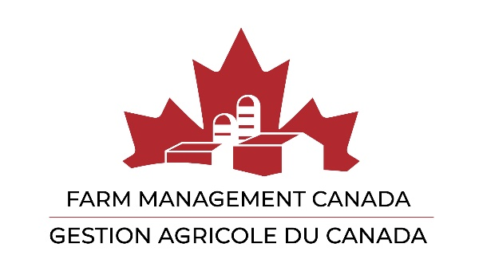

Resolution from Members

Preparation Form

Member Name:

Date:

The title of what you’d like to put forward as a resolution:

The detail of what you’d like to put forward, e.g. three bullets:

A one-sentence summary of your resolution in the form that you would like it passed:

