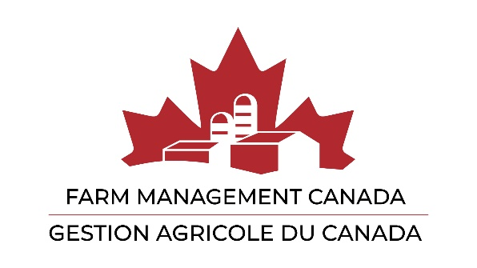

**Call for Member Resolutions 2025**

What can we do for you?

Farm Management Canada encourages its members to submit resolutions to be addressed at the Annual General Meeting.

This is an opportunity to influence the direction of Farm Management Canada’s activities, as well as the organization itself. What better way to make our Board, staff and the membership, aware of issues and items that are important to you?

A Resolution Preparation Form is available in electronic form, and copied below, for those wishing to submit resolutions.

Members are encouraged to seek background information and find out what Farm Management Canada may have already done before submitting a resolution. See our website [www.fmc-gac.com](http://www.fmc-gac.com) for information on activities and initiatives or contact us at info@fmc-gac.c.com.

Please ensure the resolution is germane to Farm Management Canada's mission and mandate:

**Vision**

A resilient and thriving Canadian agricultural industry.

**Mission**

To champion farm management excellence.

**Purpose**

To be the Canadian organization that facilitates the advancement of farm management practices through knowledge creation, curation, and extension.

**Objectives:**

1. Provide Industry Leadership

Be the national voice and champion for farm management excellence.

1. Advance Industry Knowledge

Be the curator and go-to resource for farm management expertise, learning opportunities, resources, and tools.

1. Promote Industry Success

Share the positive outcomes of farm management practices to increase adoption and implementation.

1. Enhance Strategic Partnerships

Foster and nurture strategic partnerships to maximize reach, impact and ensure organizational sustainability.

Resolutions that are accepted and not addressed or debated at the Annual General Meeting will be presented at the first meeting of the new Board of Directors following the Annual General Meeting.

A proposed resolution bearing the signature of a member or members in good standing must be received prior to May 9th 2025 at [info@fmc-gac.com](mailto:info@fmc-gac.com)

Resolutions will be accepted in written form only by email.

Please contact us if you have any questions, comments or require more information.

We will be happy to help you turn your idea into a resolution.

~The Farm Management Canada Team

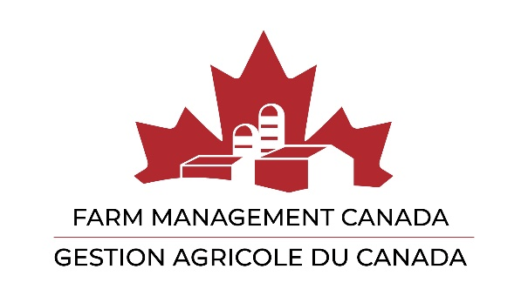

Resolution from Members

Preparation Form

Member Name:

Date:

The title of what you’d like to put forward as a resolution:

The detail of what you’d like to put forward, e.g. three bullets:

A one-sentence summary of your resolution in the form that you would like it passed: