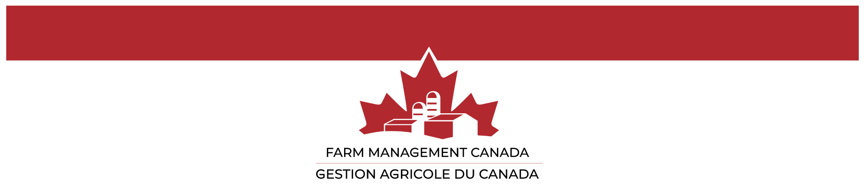

Nomination Form for the Wilson Loree Award 2025

1. Name of nominee:

2. Nominee’s email address, mailing address and telephone number:

3. Nominee’s education and work experience:

4. Nominee's accomplishments – outline the reasons why the nominee should be considered for this award (500 words or less):

5. Name of nominator, contact info and signature:

Please include two (2) Letters of Reference and send to info@fmc-gac.com
before October 3rd, 2025 with the subject line: Wilson Loree Award

