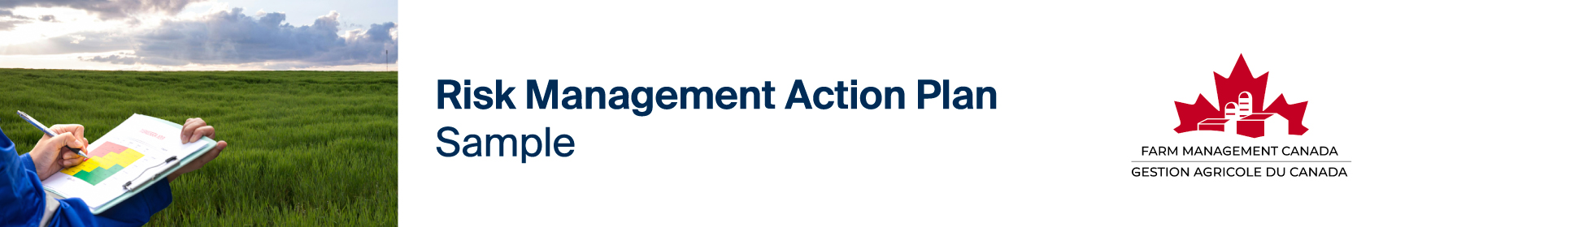

Once you have identified, assessed, and prioritized your risks, you can use a chart like the sample below to create your Risk Management Action Plan. List your risks by risk type under each priority, decide on your risk management strategy, and record a specific action or actions to undertake to manage each risk including who is responsible, and a deadline to take action. You can revisit this simple Action Plan on a regular basis to track your progress in managing farm risk. For more in-depth help identifying, assessing, and prioritizing your risks, consult the Risk Management Assessment and Planning Spreadsheet as part of the Risk Management Bundle.

Farm Name: Sunny Acres Date: June 30, 2026 Completed by: John, Jane, James and Jill
Risk Type:  People, Finance, Markets, Business Strategy, Business Environment, Production | Specific Risk | Risk Management Strategy:  Avoid  Reduce  Transfer  Retain | Risk management practice to apply | Person(s) Responsible | Target Deadline | Status:  Complete  In Progress  Not Started  Ongoing

VERY HIGH PRIORITY
Production | Drought | Transfer the Risk | Secure crop insurance and increase water storage capacity | John and James | February | Complete
Markets & Finance | Price Volatility | Reduce the Risk | Recalculate our cost of production and forward contract our crops | James | February | In Progress

HIGH PRIORITY
People | Labour for Harvest | Reduce the Risk | Advertise 3 months earlier than usual | Jill | June | Complete
Production | Flooding | Transfer the Risk | Secure crop insurance | John and James | February | Complete
People | Work-Life Balance | Reduce the Risk | Research opportunity to join a peer group to support work-life balance | Jane | March | In Progress
Business Environment | Environmental Regulations | Reduce the Risk | Get more involved in local commodity organization to stay informed of changes | John | November | Not Started

MEDIUM PRIORITY
Business Strategy | Farm Transition | Avoid the risk | Talk to the kids about their interest in taking over the farm | John and Jane | November | Not started
Business Strategy | Business Structure | Reduce the Risk | Meet with the accountant and lawyer to discuss the benefits/risks of incorporation | John and Jane | January | Not started
Finance | Debt Management | Reduce the Risk | Meet with lenders to assess debt | John and Jane | December | Not started
Production | Pest Management | Reduce the Risk | Research integrated pest management strategies | James | December | Not started
People | Family Relations | Reduce the Risk | Host a family meeting to discuss the farm’s performance and plans for the future | John, Jane,  James, Jill | October | Not started

LOW PRIORITY
Finance | Cash Flow | Retain the Risk | Continue to monitor to identify any shortcomings | Jane | Quarterly | Ongoing
People | Farm Safety | Avoid the Risk | Continue to provide farm safety training | Jill | Semi-Annually | Ongoing
Business Environment | Public Trust | Reduce the Risk | Continue to participate in agricultural advocacy community events | Jill | At Least Twice  Per Year | Ongoing

Risk management isn’t one-and-done. It’s a good idea to revisit this exercise at least once a year. And don’t forget, risk management planning is part of your overall farm business management strategy. Your risk management plan should be incorporated into your overall business plan.

For additional support, consult the Risk Management Starter Guide as part of the Risk Management Bundle.


Farm Management Canada gratefully acknowledges the support of Farm Credit Canada (FCC) in the development of this resource.

