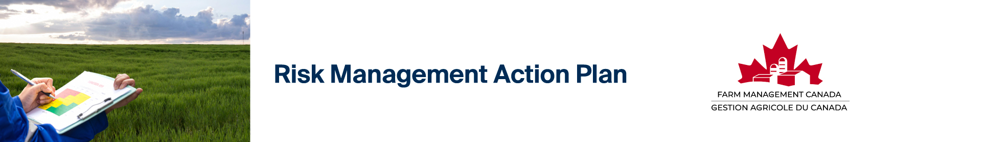

Once you have identified, assessed, and prioritized your risks, you can use the template below to create your Risk Management Action Plan. List your risks by risk type under each priority, decide on your risk management strategy, and record a specific action or actions to undertake to manage each risk including who is responsible, and a deadline to take action. You can revisit this simple Action Plan on a regular basis to track your progress in managing farm risk. For more in-depth help identifying, assessing, and prioritizing your risks, consult the Risk Management Assessment and Planning Spreadsheet and for guidance in filling in your Action Plan, you can consult the Risk Management Action Plan Sample – both included in the Risk Management Bundle.

Farm Name: Date: Completed by:
Risk Type:  People, Finance, Markets, Business Strategy, Business Environment, Production | Specific Risk | Risk Management Strategy:  Avoid  Reduce  Transfer  Retain | Risk management practice to apply | Person(s) Responsible | Target Deadline | Status:  Complete  In Progress  Not Started  Ongoing

VERY HIGH PRIORITY

HIGH PRIORITY

MEDIUM PRIORITY

LOW PRIORITY

Hint: If you need to add rows to any of the tables above, hover your mouse cursor over the left-hand side of the last row of the table and click the blue + sign,
or right-click on any cell in the last row of the table and click ‘Insert’ then ‘Insert Row Below’
To remove an unwanted row, right-click on any cell in that row, click ‘Delete Cells’ then ‘Delete Entire Row’

Risk management isn’t one-and-done. It’s a good idea to revisit this exercise at least once a year. And don’t forget, risk management planning is part of your overall farm business management strategy. Your risk management plan should be incorporated into your overall business plan.

For additional support, consult the Risk Management Starter Guide as part of the Risk Management Bundle.


Farm Management Canada gratefully acknowledges the support of Farm Credit Canada (FCC) in the development of this resource.

